How can we pay off the global coronavirus debts? Tackle the powerful
Ben Tippet
This article is more than 7 months old
Shutting down tax havens and cancelling debts could pay for the pandemic and more – if countries work together
- Coronavirus – latest updates
- See all our coronavirus coverage
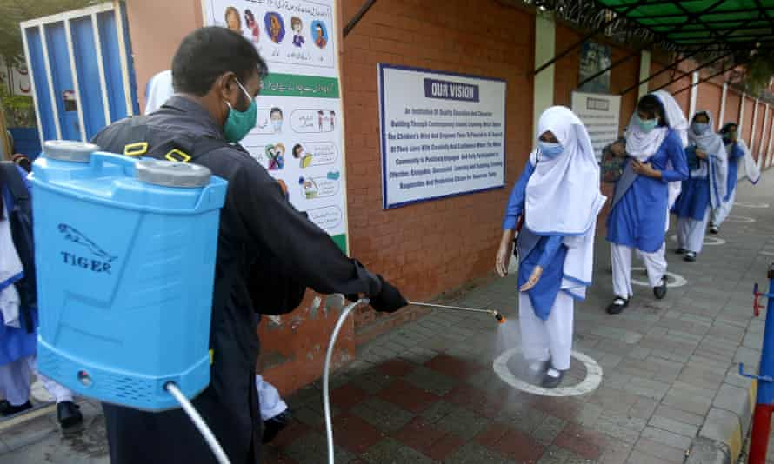
‘Many poorer countries already face dangerous amounts of indebtedness, with 64 countries currently paying more on debt servicing than on healthcare.’ A student has her shoes disinfected at a school in Lahore, Pakistan. Photograph: KM Chaudary/AP
Mon 23 Nov 2020 10.22 GMT

540

Covid-19 has hit the global economy hard. Governments around the world have already injected $11tn in fiscal measures to keep the economy afloat, and the United Nations’ conference on trade and development (Unctad) calculates that low-income countries will require an extra $2.5tn immediately to prevent economic collapse. Failure to address the economic fallout will have devastating consequences.
In answer to the big question, how are we going to pay for this, I say: we need a global response and it needs to be progressive. I recently outlined 10 possible ways to raise $9.457tn a year over the next decade, enough to not only cover the costs of the pandemic but also to meet the investments required to address the other social and environmental crises we face.
Advertisement
Before introducing some of these proposals, it’s worth addressing the question of whether the debts need to be paid back at all. Even the International Monetary Fund (IMF) – the chief architect of austerity – is making noises that rich governments can afford to accumulate high debts without negative consequences. Just as a household can manage a bigger mortgage when the interest rate is small, it is argued that a government will have no problem servicing its repayments because rates are at a historic low. Moreover, as these governments can repay their debts in their own currency, they always have the option to print money. This is a privilege not available to any household with their mortgage. This is a welcome departure from the austerity narrative preached by governments around the world in the aftermath of the 2008 crisis. But to deal with the scale and global reach of the economic crisis we face, we need more progressive proposals to raise funds than simply “getting into more debt”.
Most importantly, many poorer countries already face dangerous amounts of indebtedness, with 64 countries currently paying more on debt servicing than on healthcare. This is not the fault of the countries themselves, but the legacy of decades of neoliberal policies and the longer history of colonial inequality. As this debt is increasingly owed in foreign currencies, these countries do not have the privilege of printing money to repay their creditors.
To deal with this, low-income countries immediately require their debts to be cancelled and money injected into their economies. Following the call of Unctad and Progressive International, the international community should cancel $1tn of the debts of low-income countries and issue $2.5tn of special drawing rights (SDRs) – the IMF’s own international currency. Just as a gift voucher frees up money to spend on other things, a country that receives SDRs can trade them for real currencies to repay foreign debts, freeing up money for healthcare and poverty reduction.
The international community is slowly coming round to these ideas. Kristalina Georgieva, the managing director of the IMF, has claimed that issuing new SDRs“isn’t off the table”, while the G20 just this month has agreed to cancel some of the debts of the poorest countries in the world. However, the G20’s plans have been criticised for not including private creditors, who increasingly hold poor countries to ransom in what David Malpass, president of the World Bank, has called “the modern equivalent of debtor’s prison”.
Debt cancellation and issuing SDRs are just two possible financing mechanisms that can support low-income countries specifically. But there are other policies that can raise money for all countries, while simultaneously tackling inequality and promoting peace. We need to realise that the question, how are we going to pay for this, should be, who is going to pay for this?
Arguing for progressive taxation will be key to winning this debate. There is a strong case for the UK chancellor, Rishi Sunak, to implement new taxes on the companies and wealthy individuals who have benefited during the pandemic. But this approach should not be limited to the UK. If implemented across the globe, an excess profit tax could raise $104bn annually and a new wealth tax $4.4tn annually – theoretically, enough to pay for all the Covid-19 spending in just a couple of years.
Global coordination can also help ensure that corporations and the wealthy do not hide their wealth in tax havens. According to the IMF, shutting down tax havens (and taxing corporate profits and hidden individual wealth at current rates in the countries where they live and sell their products) would raise $200-$600bn a year.

The 'market' won't save us from climate disaster. We must rethink our system
Read more

Clearly this will require enormous international cooperation – but there is a precedent. In 2010, President Obama passed into law the Foreign Account Tax Compliance Act which imposes automatic exchange of data between foreign banks and the US’s Internal Revenue Service. A similar exchange scheme was implemented across the world by the G20 and OECD in 2014 with a common reporting standard. While these reforms exclude low-income countries and leave considerable wealth and profits still hidden offshore, they show that public pressure, scrutiny and political will can deliver change.
Reclaiming 10% of global military spending, as called for by global campaign groups and US Senator Bernie Sanders, is another key tool which could raise $191.7bn a year globally – enough to fund 43 more World Health Organizations. If this seems utopian, consider the fact that South Korea has said that it will trim next year’s defence budget by 2% ($738m) and Thailand by 8% ($557m), with the money going instead to a disaster-relief fund and a stimulus package respectively.
The pandemic has simultaneously exposed the costs of a deeply unequal world and shown the possibilities for radical action. Political action can be mustered in a matter of weeks, if political leaders deem it necessary. However, as Gus O’Donnell, the former head of the British civil service noted, “The iron law of tax changes is that the losers scream.” Shutting down tax havens, redirecting military spending and cancelling debts will face strong resistance from the most powerful people in the world. But there is perhaps an opening in which a strong movement could give us the just recovery we need and the chance to really “build back better”.
Ben Tippet is a researcher and author of Split: Class Divides Uncovered
Topics
- Global economy
- Opinion
- Debt relief
- Tax and spending
- Tax havens
- Coronavirus
- Economics
- comment

